**HDP Service (Stop/Start)**

**Stopping Kafka Service**

1. **HDP Service (Stop)**
   1. **Open url:** [**http://10.208.28.86:8080/#/login**](http://10.208.28.86:8080/#/login)
   2. 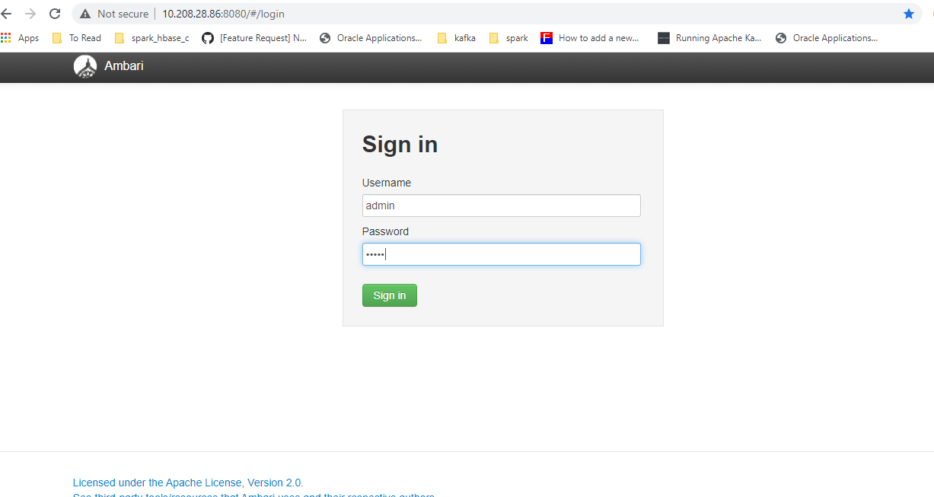**User/pass** : admin /admin

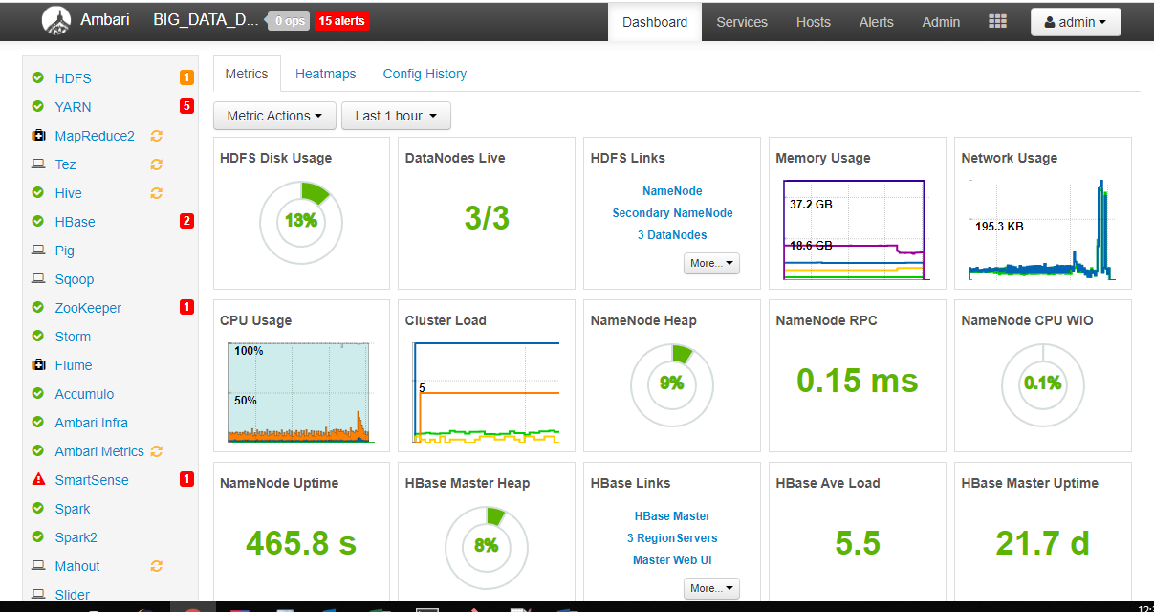

* 1. 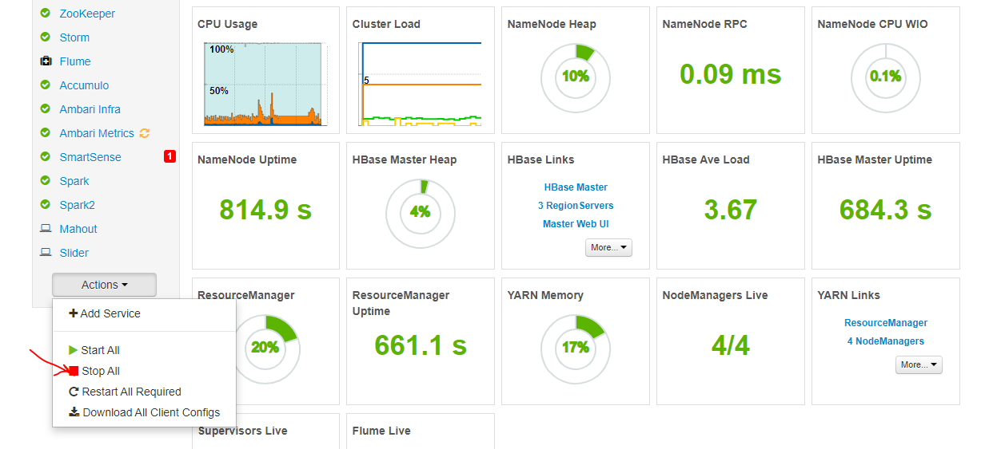**One shot stop**

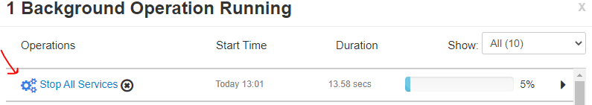

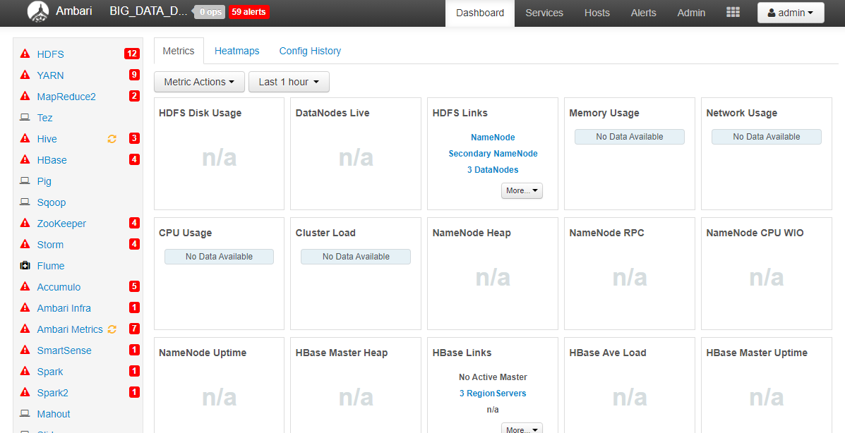

* 1. **Last Step in stopping HDP on all node:**
* 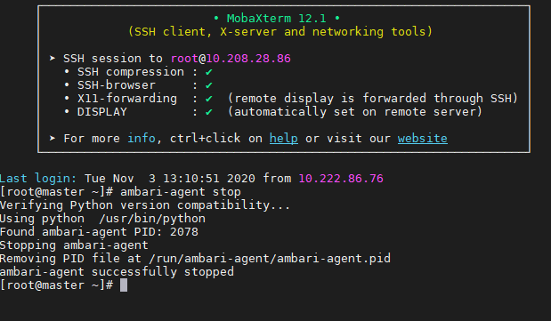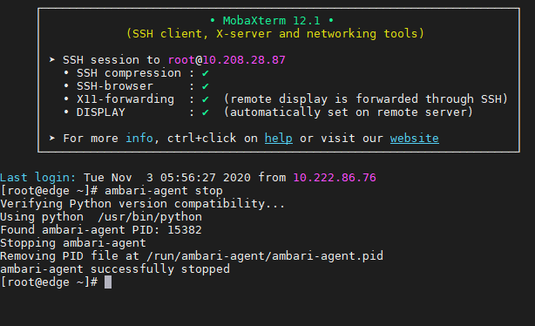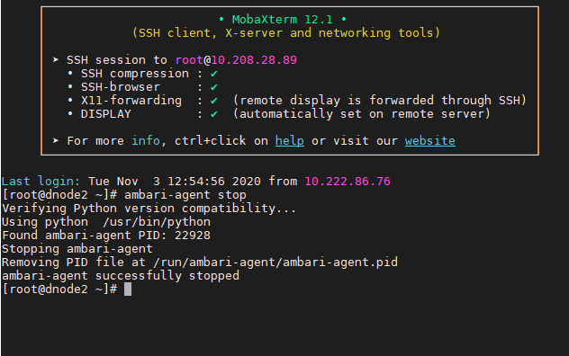**Stop ambari agents on all slaves**

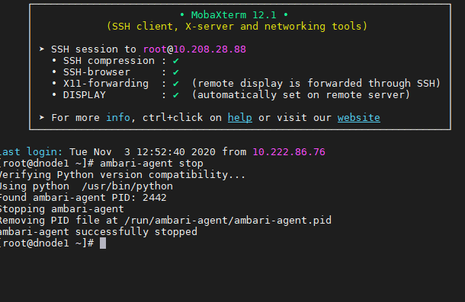

* 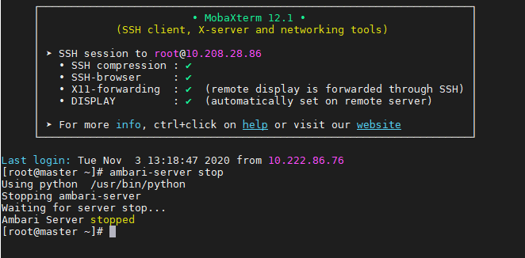**Stop ambari server on master**

**Check on all server if there is still running zombie process related to HDP**

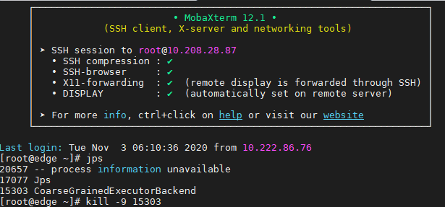

**-------------------------------------------------------------------------------------------------------------**

1. **HDP Service (Stop)**
   1. 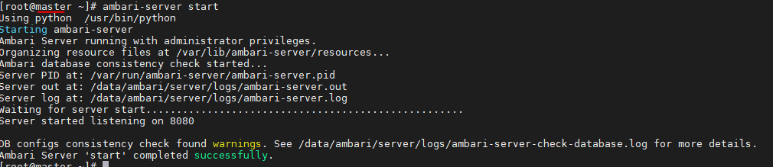**Start ambari server on master**
   2. 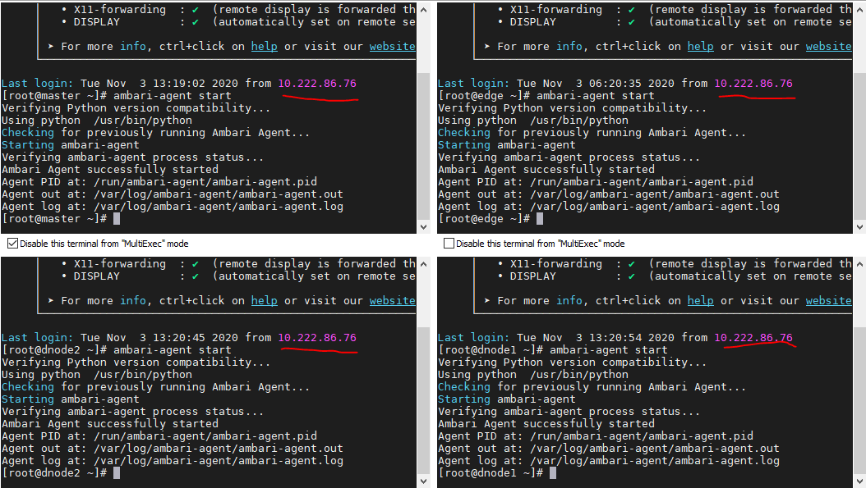**start ambari agent**
   3. 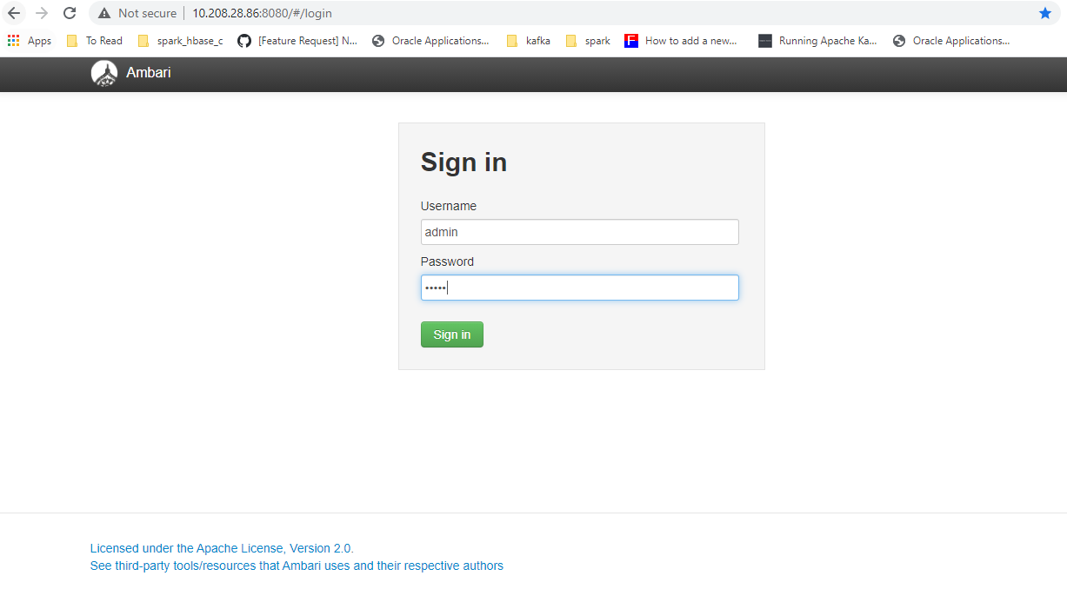**opne url:** [**http://10.208.28.86:8080/**](http://10.208.28.86:8080/)
   4. 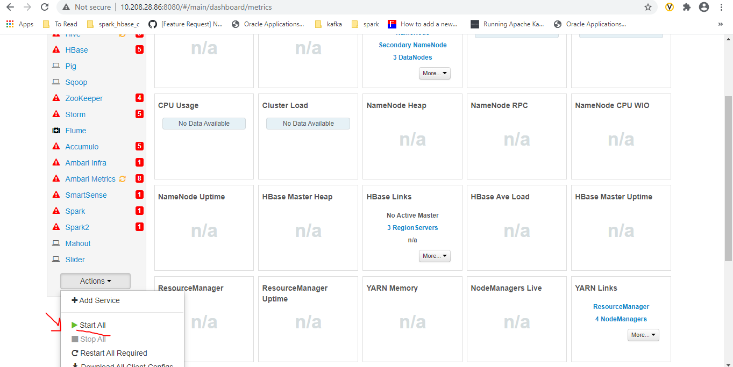**d-start all**

**Now cluster is up ☺**

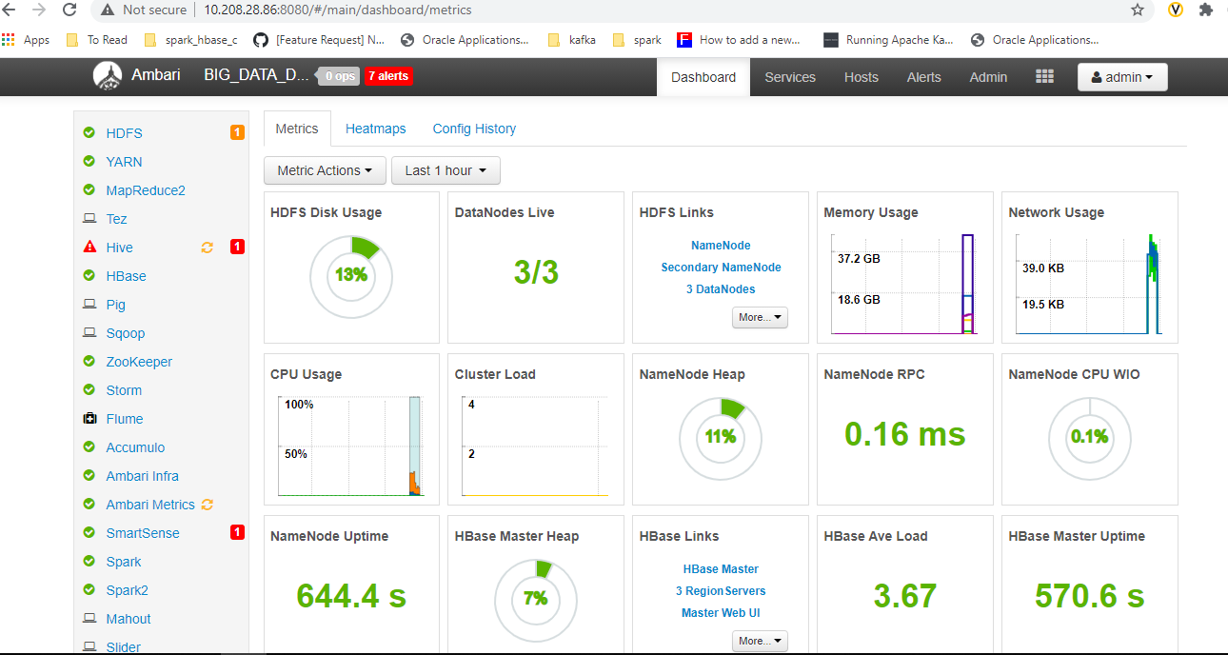

**Stop Kafka**

1. **Run below command on servers:**

10.208.28.87 , 10.208.28.88 , 10.208.28.89

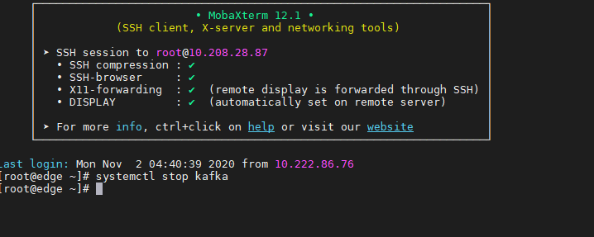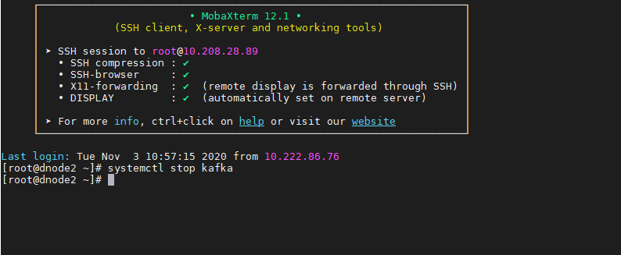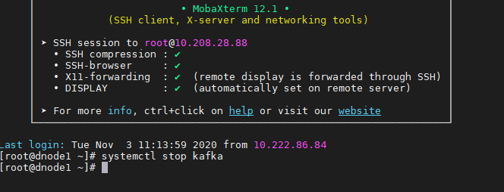**systemctl stop kafka**

* + - * + **Note that :**

**Zookeeper service is independent part out of kafka and controlled through HDP ,so if you stop zookeeper from HDP other HDP services(HDFS) will not work**

**Start Kafka**

1. **Run below command on servers:**

10.208.28.87 , 10.208.28.88 , 10.208.28.89

**systemctl start kafka**

